 | Date
Health, Safety & Environment Officer | September 2025
 | Company
 | 
Location
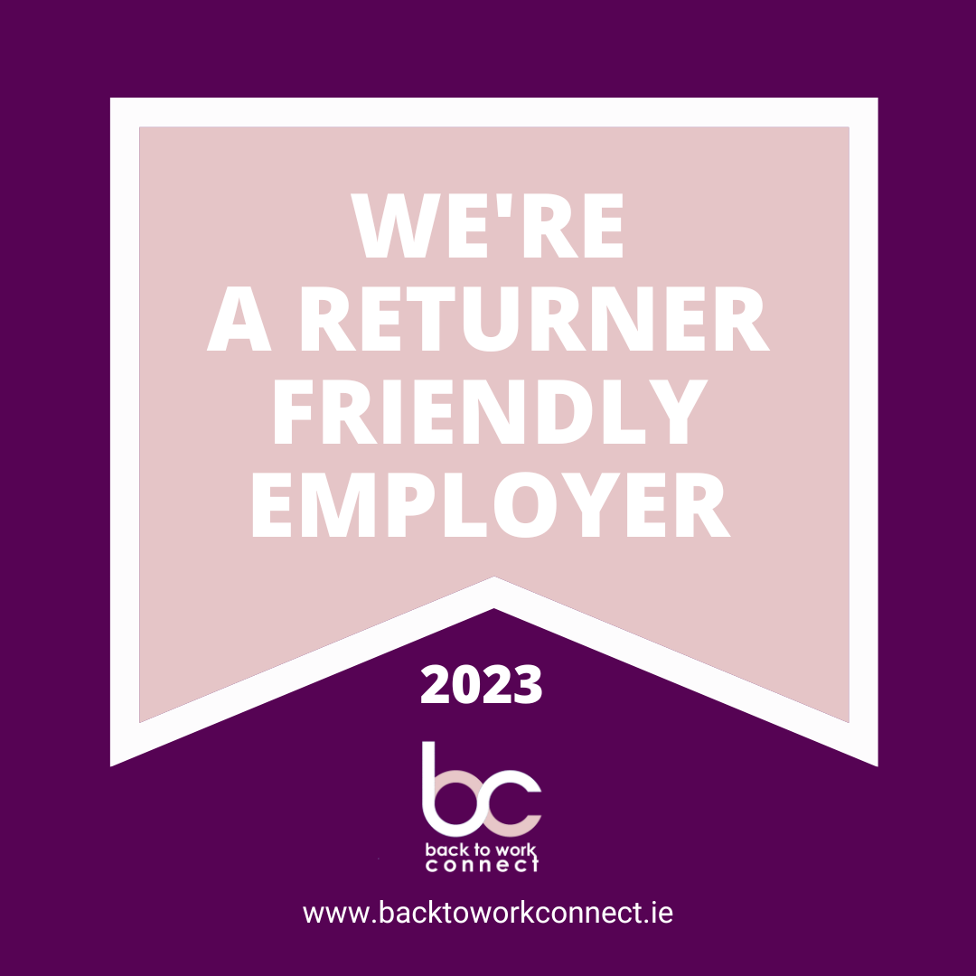
Huntstown Power Station, Dublin

Contract | 12 Month FTC – With potential for extension
Working Hours | 39 hours - Monday to Friday
Hybrid Working | We currently operate a hybrid working policy with a mix of working from the office and home.

About Us

Energia Group is a leading energy company in both RoI and NI, dedicated to decarbonising Ireland's energy system. Through three key units—Renewables, Flexible Generation, and Customer Solutions (Energia in RoI, Power NI in NI)—we offer advanced energy solutions. We're committed to driving Ireland’s renewable future and supporting local communities through initiatives like employee volunteering and community benefit funds.

Energia Group has invested €3bn in the Positive Energy programme, focusing on renewable energy projects such as wind, solar, battery storage, and green hydrogen. This initiative aims to add 2.6 GW of renewable capacity by 2030 to meet government targets and achieve Net Zero. Currently, we own and operate 360 MW of wind assets and purchase electricity from 1,190 MW of renewable capacity in Ireland. We are progressing with further onshore windfarms, solar farms, hydrogen production and battery storage to help decarbonise the energy system.

Our talented employees are our greatest asset, and we invest in their growth through Learning and Development programmes. We foster a safe, inclusive work environment, champion diversity, and are seeking people with positive energy to make an impact in their roles through a meaningful career with us.

About the Role

This is a 12 month fixed term contract to cover a period of maternity leave This key role sits within our Renewables Operations team and will report into the Planning & Environmental Officer. The Renewable Operations department currently oversees the HS&E across 17 operational sites and the 25 staff who operate them. This role will be responsible for coordinating, supporting, and advising the team on all aspects of H&S. This role is mainly office based in Dublin 11, with travel to renewables sites required from time to time.

Responsibilities
Day-to-day, here’s what your new role would look like:
- Manage day to day H&S queries and requests from the team.
- Manage raising, follow up and close out of Operational Restrictions, Incident Reports, Safety Bulletins, Good Catches & statutory inspections
- Manage and record site inductions for the team
- Manage and update site HSE documents, procedures and risk assessments
- Manage HSE training matrix and organise training for the team as required
- Review and approve contractor RAMS - Involvement in projects as required

About you

Key Criteria – What You’ll Need
- Full clean driving licence and access to a vehicle (main office and sites are not accessible by public transport)
- At least 3 years experience in a similar health and safety role, experience working in an Electrical Generation environment is an advantage.
- Proficient in using Word, Excel and PowerPoint
- Good understanding of HSE regulations and compliance standards in both ROI and NI

Desirable Criteria - These help decide between those who meet all the above key criteria:
- Experience in Environmental management and ESG
- Ability to work in both ROI and NI, sites and offices are located in both regions

If you are enthusiastic about this role but don’t meet every single requirement, we still encourage you to apply. Your past experiences might be the perfect match for this or other positions, making you the unique talent we’re looking for.

Energised for better
These are the behaviours, skills, and knowledge you need to be successful in our organisation:
  Leading  Self  Effective Collaboration  Flexibility, Agility  & Resilience |  | Achieving  Success  Critical Thinking &  Problem-Solving

Why you’ll love it here
 |  |  |  |  | 
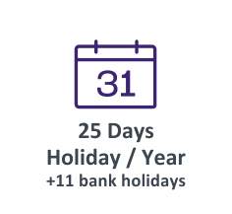 | 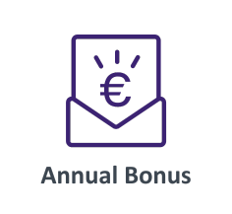 |  | 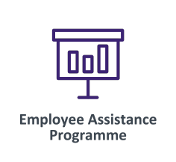 | 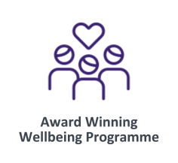 |  | 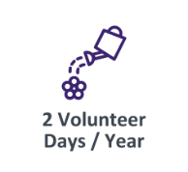 | 
 | 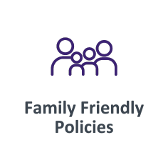 |  |  |  |  |  | 
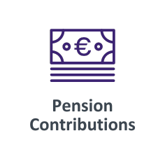 |  |  | 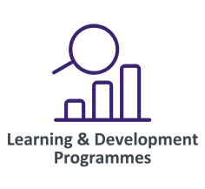 | 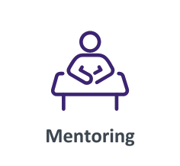 |  | 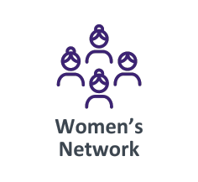 | 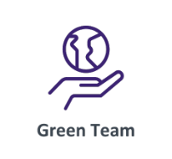
Awards


- Bronze Diversity Mark

- Best Storytelling Award (Spider Awards)

- Business Working Responsibly Mark for responsible and sustainable business practices

Bronze Diversity Mark

- Special Award for CSR and Charitable Initiatives (UK Utilities & Telecom Awards)

- Utility Week Awards 2024 - Finalist

- Silver in Social Sustainability, Diversity and Inclusion initiative of the Year (Greener Possibilities)

- ESG Best Performer of the Year in the Green Awards

- Best Corporate Wellbeing Programme

- Women in STEM - Best Recruitment Campaign

